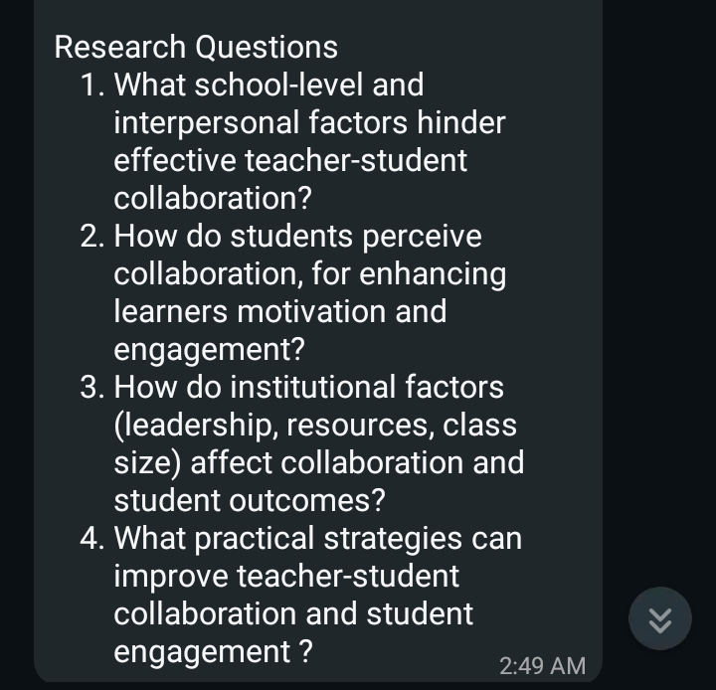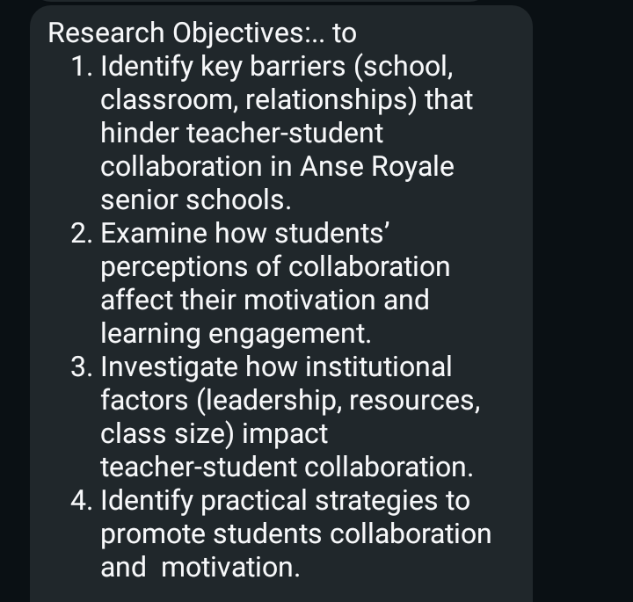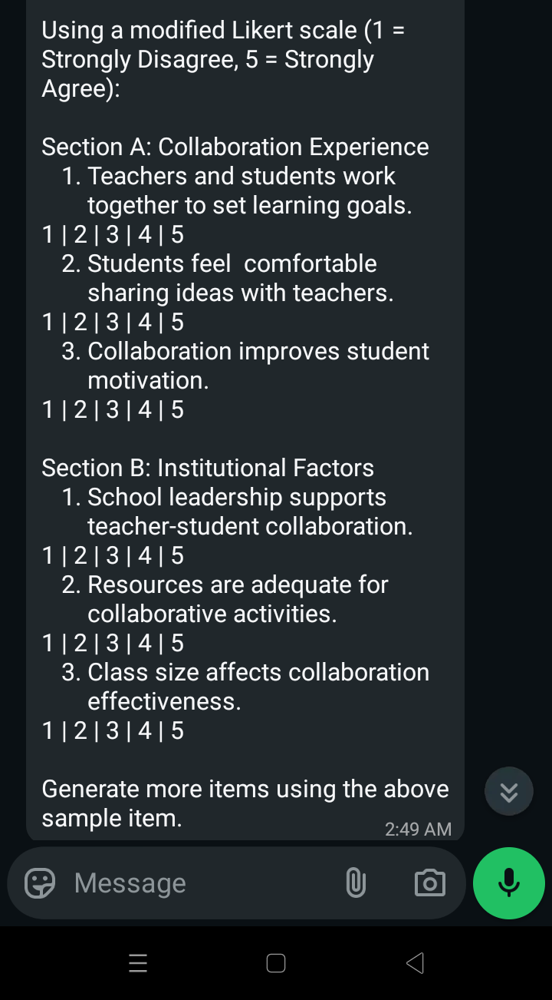
Using the Research objectives and research questions, generate more items of students' questionnaire using the above sample of the Likert scale to
- PROVIDE 5 ITEMS FOR COLLABORATION.
- PROVIDE 5 ITEMS FOR MOTIVATION.
- PROVIDE Using 5 ITEMS FOR ENGAGEMENT.
- PROVIDE 5 ITEMS FOR BARRIERS TO COLLABORATION

